User Interface Prototypes

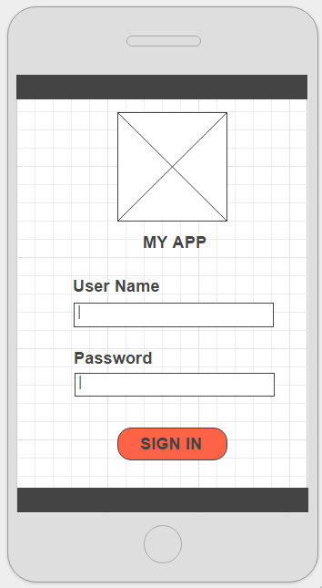

Figure : Page 1

*Note: this is just an example. Replace it with appropriate diagrams. One diagram for each page of your application. All pages must be prototyped.*